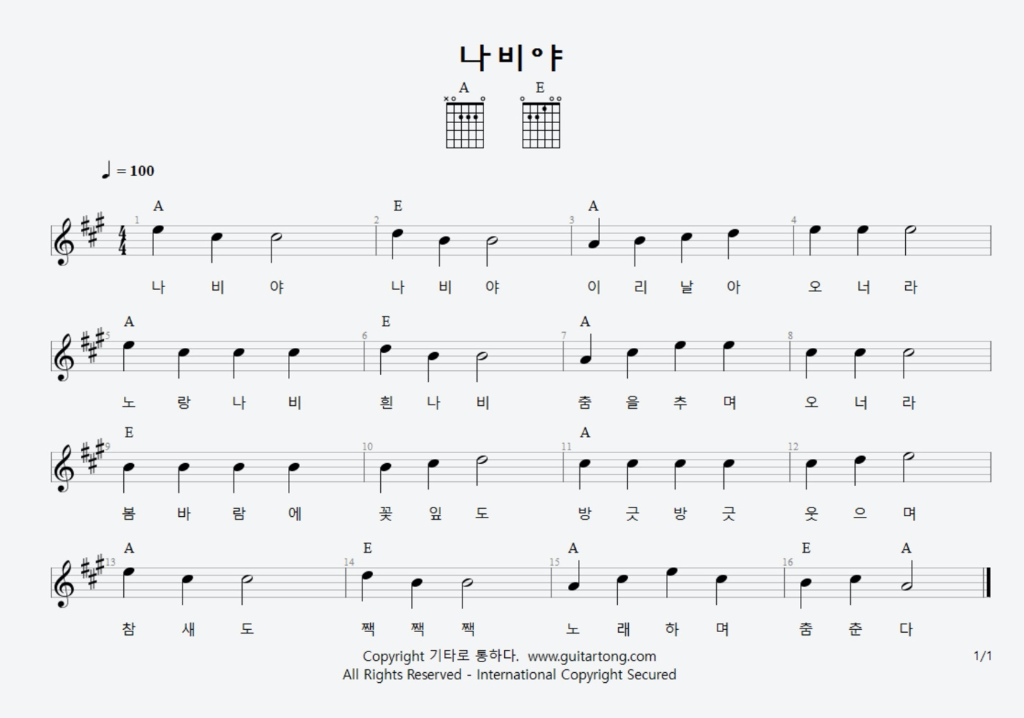

A E A
November, November, This month’s name is November
A E A
November has Thanksgiving, November has Thanksgiving
E A
In November, we give thanks, In November, we give thanks!
A E A E A
November, November, this month’s name is November!

